Murat Ozbek

Location: Dubai, United Arab Emirates | Phone: +971 56 727 1639 | Email: muratozbek14@gmail.com | LinkedIn Profile

Manager - level Project Management Professional
Senior Project Manager | PMO Lead | Senior Scrum Master | Agile Delivery Lead
Project Management, Product Management, Agile Delivery, Digital Transformation
Stakeholder Management, Business Development, Team Leadership

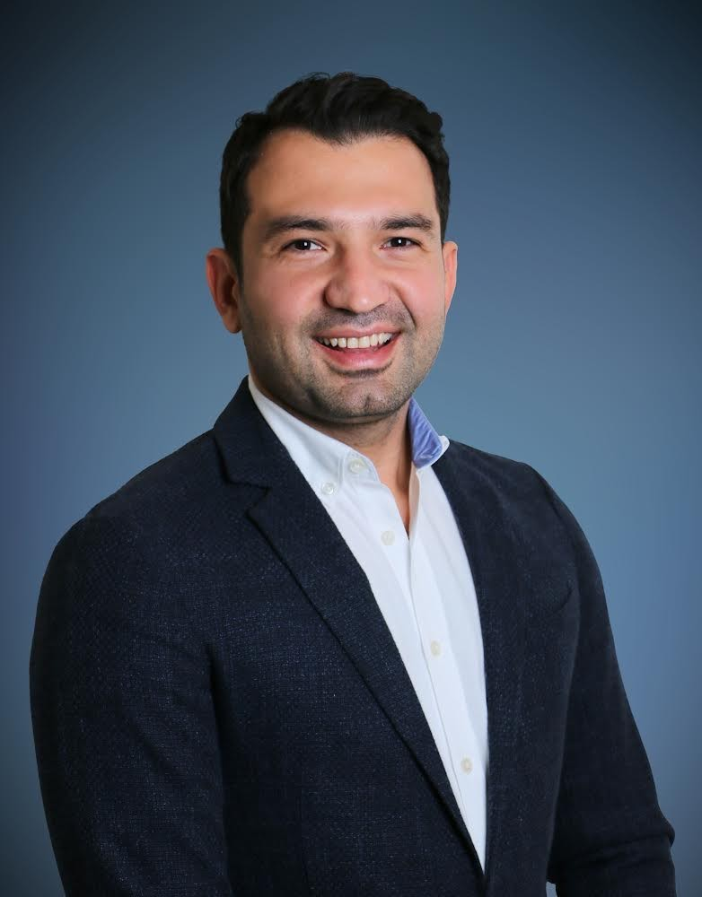
With over 12 years of experience in IT, I’m a result-driven Senior Project Manager specializing in delivering complex digital and Agile transformation projects. My expertise spans project management, product management, and Agile delivery, with a proven track record of driving significant improvements and optimizing performance across diverse industries.

Expertise in managing high-profile projects, bridging communication gaps between stakeholders and technical teams, and fostering a collaborative environment maximizes team potential. A strategic approach to stakeholder management and performance evaluation ensures successful project outcomes and enhances business development opportunities.

Passionate about technology and innovation, I thrive in fast-paced environments, focusing on building strong, motivated teams and ensuring transparent communication. My leadership empowers individuals to achieve their best and drive impactful results.

- Skills

Project Management Manages project plans, aligning timelines and budgets to align with business goals
Agile Methodologies Leads Agile transformations, implementing Scrum, SAFe, Kanban, and Lean practices
Product Management Manages product lifecycle, ensuring market alignment with business strategy
Team Leadership Builds, coaches & leads large teams of up to 50 people to deliver objectives
Stakeholder Management Being the primary contact for project stakeholders, ensuring clear communications
Performance Management Achieves performance optimization through effective KPI management
Risk Management Implements effective risk & opportunities identification & resolution strategies
Budget Management Manage project budgets and ensuring that project delivered within approved budget
Business Development Drives strategic partnerships to position company as a leading industry player
Strategic Planning Develops and implements long-term strategies to achieve business goals
Process Improvement Identifies inefficiencies and implements process improvements to enhance productivity
Resource Management Lead cross-functional teams, allocate resources effectively
Documentation & Reporting Maintain detailed project documentation, including project plan, status report & risk logs
Data Analysis Utilizes data-driven insights to inform decision-making and optimize performance
Release Management Coordinates the successful release of products, ensuring seamless deployment
Project Management Tools MS Project, JIRA, Asana, Azure DevOps, ClickUp, Confluence, Notion, Smartsheet
Data Visualization Tools Power BI, Tableu, Looker, QlikView
Languages English (fluent), Turkish (native)

- Selected Projects & Accomplishments
- Digital Transformation & Healthcare Project: Pfizer Bold Moves 3.3 Project at IBM -> Project Link
  - Ensured successful go-live with zero critical issues: Managed the go-live phase of the digital platforms, ensuring zero critical issues at launch and a seamless transition from development to operational use.
  - Accelerated project delivery through Agile methodologies: Successfully implemented Agile frameworks (Scrum, SAFe) to accelerate project delivery by 30%, ensuring adaptability to changes and continuous improvement across teams.
  - Expanded digital health capabilities globally: Collaborated with regional teams to deploy digital health solutions in over 38 countries, accelerating the work of healthcare professionals, enhancing software systems, eliminating human errors, improving patient outcomes, and reducing costs by integrating physical and digital experiences, including mobile and web-based solutions.
- Artificial Intelligence (AI) Project: Afiniti/Avaya - Contact Center Intelligent Agent to Customer Pairing -> Link
  - Led Agile-based development: Directed cross-functional teams in the integration of AI-driven pairing technology, ensuring timely delivery and maintaining high code quality.
  - Streamlined stakeholder communication: Facilitated clear communication between product owners, stakeholders, and cross-functional teams, reducing project impediments by 20%.
  - Improved technical delivery and development efficiency: Implemented automated test management and defect tracking, reducing resolution time by 10%, while optimizing Agile metrics to boost sprint efficiency by 15%, removing technical bottlenecks, and minimizing risks.
- Aviation, Loyalty Management & E-commerce Projects: Amadeus Loyalty Management Program -> Link
  - Successfully launched TAP Air Portugal's TAP Store: Led the development and deployment of the airline’s first integrated online shopping platform, ensuring a seamless customer experience by coordinating cross-functional teams and optimizing platform performance for high traffic demands.
  - Enhanced loyalty program efficiency: Led the implementation of key upgrades to the Alfursan Miles program, streamlining reward redemption processes and improving member engagement, contributing to a 15% increase in active user participation and driving greater customer loyalty for Saudi Arabian Airlines.
  - Transformed loyalty program personalization: Implemented advanced data-driven personalization strategies for Mileage Plus, resulting in a significant increase in customer engagement and a higher rate of loyalty rewards redemption, boosting overall customer satisfaction and loyalty for United Airlines.

- Work Experience

January 2022 – Present
Agile Project Manager – IBM, UAE

- Guided the digital transformation of Pfizer's mobile and web platforms, optimizing performance, improving user experience, and accelerating healthcare service delivery for healthcare professionals.
- Led global Agile teams across the USA, UK, Germany, France, Italy, Turkey, Saudi Arabia, and UAE, aligning strategic goals and delivering a more agile operating model for digital initiatives.
- Developed and deployed mobile and web-based digital solutions, enhancing Pfizer’s digital health capabilities, improving data integration, reducing human errors, and boosting operational efficiency.
- Mentored and coached Agile teams, embedding Agile principles (Scrum, SAFe, Kanban) across a global, cross-functional team of over 50 members, driving continuous improvement.
- Defined and tracked key success metrics (KPIs, SLAs), ensuring high-impact solution delivery while meeting performance and compliance standards in the healthcare sector.
- Facilitated Agile ceremonies (daily stand-ups, sprint planning, retrospectives), ensuring timely completion of project milestones and fostering a culture of transparency and collaboration.
- Collaborated with engineering, product management, and compliance teams to align on project goals, manage the backlog, prioritize tasks, and ensure regulatory compliance across international markets.
- Managed stakeholder relationships and developed a strategic project roadmap, aligning digital health initiatives with Pfizer’s business goals, while ensuring resource allocation, risk management, and issue resolution.
- Navigated complex regulatory requirements and partnered with local agencies to ensure the localization of digital solutions, guaranteeing compliance with health standards across diverse markets.

September 2020 – January 2022
Technical Project Manager/Scrum Master – Afiniti, USA(Remote)

- Led cross-functional Agile teams across the USA, UK, Canada, India, Pakistan, and the Philippines in the development and deployment of AI-driven customer-agent pairing solutions, optimizing the use of machine learning models in a B2B environment.
- Facilitated Agile Scrum processes to manage the full software development lifecycle, ensuring seamless collaboration between development, QA, and business stakeholders to deliver high-value AI and machine learning products.
- Collaborated with product owners and key stakeholders to define project requirements, prioritize the backlog, and allocate resources effectively, ensuring alignment with strategic goals and on-time delivery.
- Drove project transparency through effective communication, regular sprint reviews, status reports, and daily stand-ups, while ensuring continuous risk assessment and issue resolution to mitigate project delays.
- Managed the end-to-end delivery of AI-powered solutions by overseeing project timelines, budgets, and resource allocation, ensuring alignment with client expectations and maintaining high standards of quality.
- Facilitated technical and design reviews, leading discussions on key project decisions and problem-solving, while fostering a culture of psychological safety and innovation within the team.
- Implemented Agile best practices (Scrum, Kanban) to enhance team performance and operational efficiency, including backlog grooming, sprint planning, and retrospectives, driving improvements in delivery and stakeholder satisfaction.
- Developed and implemented PMO policies and frameworks, ensuring consistent project management practices, improving reporting structures, and establishing performance metrics for ongoing success.
January 2019 – September 2020
Technical Product Manager – Ericsson, Turkey
- Led digital transformation projects for key clients like Vodafone, overseeing the development and enhancement of mobile & web-based solutions, aligning with client objectives and delivering innovative digital experiences.
- Managed the full product lifecycle of multiple web and mobile application projects, from requirement analysis and backlog prioritization to execution and delivery, ensuring timely completion while meeting business goals.
- Collaborated with cross-functional teams (engineering, UX/UI, marketing) to define product features and translate business needs into technical tasks, ensuring seamless integration across platforms.
- Drove Agile development processes, facilitating sprint planning, backlog grooming, and iteration delivery to ensure continuous improvement and on-time release of high-quality solutions.
- Championed user experience (UX) by guiding the development of customer-centric features, conducting usability testing, and making data-driven decisions to enhance digital platform usability.

September 2015 – December 2018
Product Manager – Amadeus IT Group, Turkey
- Led product development for international airline loyalty programs, delivering enhancements and new features for clients like United Airlines, TAP Air Portugal, and Saudi Arabian Airlines, ensuring on-time, in-scope delivery.
- Defined and executed product strategy and vision, collaborating with airline clients and internal stakeholders to translate complex business needs into innovative loyalty and e-commerce solutions.
- Managed the end-to-end product lifecycle, from gathering requirements and conducting feasibility studies to overseeing development, testing, and successful implementation of loyalty and e-commerce platforms.
- Facilitated cross-functional collaboration between airlines, development teams, and business units, ensuring clear communication, alignment with Agile principles, and seamless delivery of solutions.
- Drove innovation in loyalty and e-commerce solutions, collaborating with clients to ideate, prioritize, and develop new functionalities that enhanced customer engagement and satisfaction.
- Conducted competitive analysis and managed third-party partnerships, working with external vendors to integrate services into Amadeus platforms while maintaining a competitive edge in the market.
- Authored technical and functional documentation, including product specifications, interface control documents, and solution overviews, presenting walkthroughs and feasibility studies to stakeholders for feedback and alignment.

September 2012 – September 2015
Senior IT Project Engineer – Garanti BBVA Technology, Turkey (On-site)
- Led IT infrastructure projects for contact center and security systems, ensuring the successful integration of both hardware and software components to meet the company’s technical requirements and security standards.
- Collaborated with project managers and cross-functional teams to plan, organize, and control resources effectively, delivering complex projects on time and within budget.
- Researched and implemented new technologies, developing infrastructure strategies to enhance system performance and reduce costs and risks associated with security and IT processes.
- Provided technical support for user management, troubleshooting, and system maintenance, ensuring continuous operation of critical IT systems in accordance with company specifications.
- Monitored project progress, preparing scheduling, resource allocation, and risk assessments, while coordinating with internal and external stakeholders to ensure successful project delivery and adherence to timelines.

- Certifications
- Professional Scrum Master II (PSMII) Scrum.org
- Professional Scrum Master I (PSMI) Scrum.org
- IBM CLM for SAFe IBM
- IBM Agile Explorer IBM
- IBM Artificial Intelligence Fundamentals IBM
- IBM Project Management Fundamentals IBM
- IBM Enterprise Design Thinking Practitioner IBM
- IBM Cybersecurity Fundamentals IBM
- IBM Explore Emerging Tech IBM
- Test Driven Requirements Planit Testing, Australia
- HP Application Lifecycle Management Acpqualife Groupe HPS, France
- The Professional Scrum Master Training Fonksiyon360, Turkey
- Deploying Cisco Unified Contact Center Express Course AcademyTech, Turkey
- Cisco Collaboration Sales Specialist Certification Cisco Systems Inc, Netherlands
- Cisco Physical Security Training: Access Control Cisco Systems Inc, Netherlands
- Cisco Physical Security Training: IP Video Surveillance Cisco Systems Inc, Netherlands
- Education
MSc, Engineering & Technology Management Bogazici University 2016
BSc, Electronics Engineering Sabanci University 2012

